**NAME: PATEL JAIMINI SHAILESHKUMAR**

**ROLLNO: 37**

**SYMCA-SEM-IV**

**SUBJECT: IMAGE PROCESSING AND COMPUTER VISION**

**Ex no: 1**

**Date: 28-11-2019**

**Problem Statement:**

Write a Python graphics program to print your fullname in English using basic shapes.

**Program:**

from graphics import *

w=GraphWin("alpha",1000,700)

l=Line(Point(0,10),Point(1000,10))

l.draw(w)

l.setWidth(3)

l.setOutline("red")

l=Line(Point(0,650),Point(1000,650))

l.draw(w)

l.setWidth(3)

l.setOutline("red")

#J

l=Line(Point(10,100),Point(200,100))

l.draw(w)

l.setWidth(3)

l.setOutline("red")

l=Line(Point(100,200),Point(100,100))

l.draw(w)

l.setWidth(3)

l.setOutline("red")

l=Arc(Point(100,250),Point(30,150),0,-180,"arc")

l.draw(w)

l.setOutline("red")

l.setWidth(3)

#A

l=Line(Point(240,100),Point(200,250))

l.draw(w)

l.setWidth(3)

l.setOutline("red")

l=Line(Point(240,100),Point(300,250))

l.draw(w)

l.setWidth(3)

l.setOutline("red")

l=Line(Point(215,200),Point(280,200))

l.draw(w)

l.setWidth(3)

l.setOutline("red")

#I

l=Line(Point(320,100),Point(450,100))

l.draw(w)

l.setWidth(3)

l.setOutline("red")

l=Line(Point(380,250),Point(380,100))

l.draw(w)

l.setWidth(3)

l.setOutline("red")

l=Line(Point(320,250),Point(450,250))

l.draw(w)

l.setWidth(3)

l.setOutline("red")

#M

l=Line(Point(470,100),Point(470,255))

l.draw(w)

l.setWidth(3)

l.setOutline("red")

l=Line(Point(470,100),Point(520,170))

l.draw(w)

l.setWidth(3)

l.setOutline("red")

l=Line(Point(570,100),Point(520,170))

l.draw(w)

l.setWidth(3)

l.setOutline("red")

l=Line(Point(570,100),Point(570,255))

l.draw(w)

l.setWidth(3)

l.setOutline("red")

#I

l=Line(Point(590,100),Point(740,100))

l.draw(w)

l.setWidth(3)

l.setOutline("red")

l=Line(Point(665,250),Point(665,100))

l.draw(w)

l.setWidth(3)

l.setOutline("red")

l=Line(Point(590,250),Point(740,250))

l.draw(w)

l.setWidth(3)

l.setOutline("red")

#N

l=Line(Point(770,100),Point(770,255))

l.draw(w)

l.setWidth(3)

l.setOutline("red")

l=Line(Point(770,100),Point(850,250))

l.draw(w)

l.setWidth(3)

l.setOutline("red")

l=Line(Point(850,100),Point(850,250))

l.draw(w)

l.setWidth(3)

l.setOutline("red")

#I

l=Line(Point(860,100),Point(1000,100))

l.draw(w)

l.setWidth(3)

l.setOutline("red")

l=Line(Point(930,250),Point(930,100))

l.draw(w)

l.setWidth(3)

l.setOutline("red")

l=Line(Point(860,250),Point(1000,250))

l.draw(w)

l.setWidth(3)

l.setOutline("red")

#P

l=Line(Point(70,550),Point(70,350))

l.draw(w)

l.setWidth(3)

l.setOutline("red")

l=Arc(Point(0,450),Point(150,350),90,-180,"arc")

l.draw(w)

l.setOutline("red")

l.setWidth(3)

#A

l=Line(Point(170,550),Point(220,350))

l.draw(w)

l.setWidth(3)

l.setOutline("red")

l=Line(Point(280,550),Point(220,350))

l.draw(w)

l.setWidth(3)

l.setOutline("red")

l=Line(Point(188,470),Point(255,470))

l.draw(w)

l.setWidth(3)

l.setOutline("red")

#T

l=Line(Point(480,350),Point(280,350))

l.draw(w)

l.setWidth(3)

l.setOutline("red")

l=Line(Point(380,550),Point(380,350))

l.draw(w)

l.setWidth(3)

l.setOutline("red")

#E

l=Line(Point(520,550),Point(520,350))

l.draw(w)

l.setWidth(3)

l.setOutline("red")

l=Line(Point(650,350),Point(520,350))

l.draw(w)

l.setWidth(3)

l.setOutline("red")

l=Line(Point(650,450),Point(520,450))

l.draw(w)

l.setWidth(3)

l.setOutline("red")

l=Line(Point(650,550),Point(520,550))

l.draw(w)

l.setWidth(3)

l.setOutline("red")

#L

l=Line(Point(690,550),Point(690,350))

l.draw(w)

l.setWidth(3)

l.setOutline("red")

l=Line(Point(860,550),Point(690,550))

l.draw(w)

l.setWidth(3)

l.setOutline("red")

**Output:**

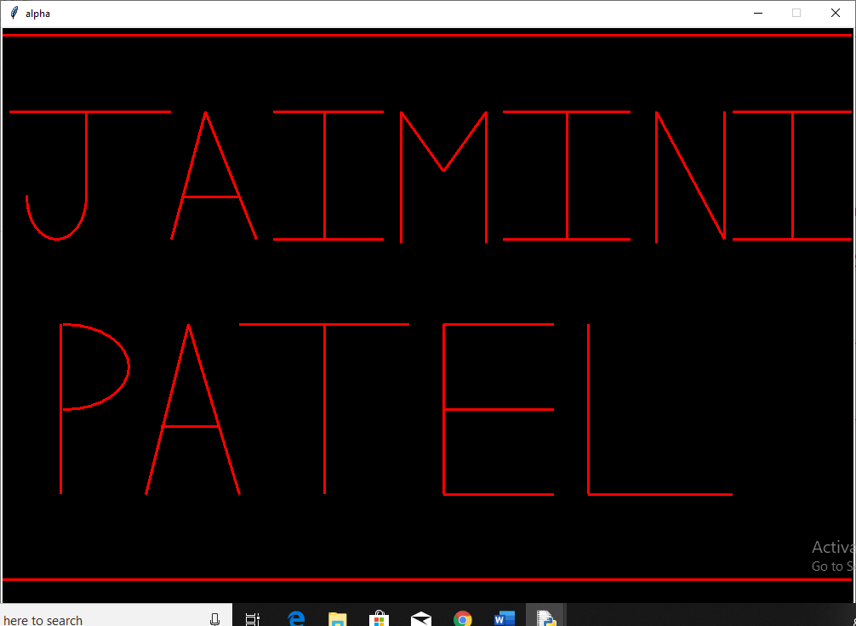

**Ex no: 2**

**Date: 28-11-2019**

**Problem Statement:**

Write a Python graphics program to print your fullname in Hindi using basic shapes.

**Program:**

from graphics import *

w=GraphWin("Hindi Name",700,700)

l=Line(Point(0,10),Point(700,10))

l.draw(w)

l.setWidth(3)

l.setOutline("blue")

l=Line(Point(0,550),Point(700,550))

l.draw(w)

l.setWidth(3)

l.setOutline("blue")

w.setBackground('black')

#Jai

l=Line(Point(260,100),Point(550,100))

l.draw(w)

l.setWidth(3)

l.setOutline("blue")

l=Line(Point(280,145),Point(340,145))

l.draw(w)

l.setWidth(3)

l.setOutline("blue")

l=Arc(Point(250,200),Point(290,110),10,-200,"arc")

l.draw(w)

l.setOutline("blue")

l.setWidth(3)

l=Line(Point(340,200),Point(340,100))

l.draw(w)

l.setWidth(3)

l.setOutline("blue")

l=Line(Point(250,45),Point(350,100))

l.draw(w)

l.setWidth(3)

l.setOutline("blue")

l=Line(Point(220,50),Point(320,100))

l.draw(w)

l.setWidth(3)

l.setOutline("blue")

#mi

l=Line(Point(430,200),Point(430,100))

l.draw(w)

l.setWidth(3)

l.setOutline("blue")

l=Line(Point(400,145),Point(430,145))

l.draw(w)

l.setWidth(3)

l.setOutline("blue")

l=Line(Point(400,170),Point(400,100))

l.draw(w)

l.setWidth(3)

l.setOutline("blue")

l=Arc(Point(400,180),Point(370,140),0,-340,"arc")

l.draw(w)

l.setOutline("blue")

l.setWidth(3)

l=Line(Point(450,200),Point(450,100))

l.draw(w)

l.setWidth(3)

l.setOutline("blue")

l=Arc(Point(450,130),Point(430,70),0,180,"arc")

l.draw(w)

l.setOutline("blue")

l.setWidth(3)

#ni

l=Line(Point(520,200),Point(520,100))

l.draw(w)

l.setWidth(3)

l.setOutline("blue")

l=Line(Point(490,147),Point(520,147))

l.draw(w)

l.setWidth(3)

l.setOutline("blue")

l=Arc(Point(490,170),Point(460,140),0,355,"arc")

l.draw(w)

l.setOutline("blue")

l.setWidth(3)

l=Line(Point(540,200),Point(540,100))

l.draw(w)

l.setWidth(3)

l.setOutline("blue")

l=Arc(Point(540,130),Point(520,70),0,180,"arc")

l.draw(w)

l.setOutline("blue")

l.setWidth(3)

#p

l=Line(Point(255,275),Point(480,275))

l.draw(w)

l.setWidth(3)

l.setOutline("blue")

l=Arc(Point(255,270),Point(300,316),140,182,"arc")

l.draw(w)

l.setOutline("blue")

l.setWidth(3)

l=Line(Point(295,277),Point(295,352))

l.draw(w)

l.setOutline("blue")

l.setWidth(3)

#t

l=Line(Point(355,277),Point(355,302))

l.draw(w)

l.setOutline("blue")

l.setWidth(3)

l=Arc(Point(320,300),Point(375,350),70,230,"arc")

l.draw(w)

l.setOutline("blue")

l.setWidth(3)

l=Line(Point(355,277),Point(325,240))

l.draw(w)

l.setOutline("blue")

l.setWidth(3)

#l

l=Line(Point(390,352),Point(376,315))

l.draw(w)

l.setOutline("blue")

l.setWidth(3)

l=Arc(Point(376,305),Point(402,325),-35,220,"arc")

l.draw(w)

l.setOutline("blue")

l.setWidth(3)

l=Arc(Point(400,305),Point(430,325),20,170,"arc")

l.draw(w)

l.setOutline("blue")

l.setWidth(3)

l=Line(Point(428,277),Point(428,352))

l.draw(w)

l.setOutline("blue")

l.setWidth(3)

**Output:**

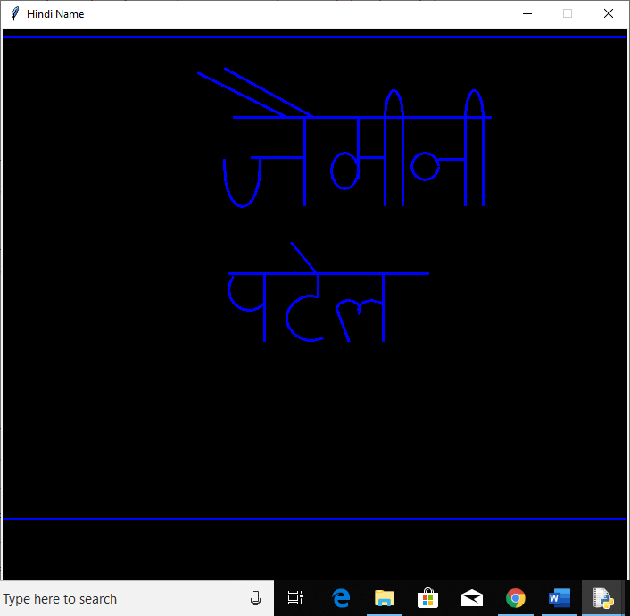

**Ex no: 3**

**Date: 28-11-2019**

**Problem Statement:**

Write a Python graphics program to print alphabets in both upper case and lower case letters using basic shapes.

**Capital letter**

**Program:**

from graphics import *

w=GraphWin("Alphabets(A-Z)",600,500)

l=Line(Point(0,10),Point(600,10))

l.draw(w)

l.setWidth(3)

l.setOutline("blue")

l=Line(Point(0,380),Point(650,380))

l.draw(w)

l.setWidth(3)

l.setOutline("blue")

w.setBackground("black")

a1=Line(Point(22,120),Point(40,20))

a2=Line(Point(60,120),Point(40,20))

a3=Line(Point(30,80),Point(50,80))

a1.setWidth(3)

a2.setWidth(3)

a3.setWidth(3)

a1.draw(w)

a2.draw(w)

a3.draw(w)

a1.setOutline("red")

a2.setOutline("red")

a3.setOutline("red")

b1=Line(Point(80,20),Point(80,120))

b2=Arc(Point(45,20),Point(120,70),270,180,"arc")

b3=Arc(Point(45,70),Point(120,120),270,180,"arc")

b1.setWidth(3)

b1.draw(w)

b2.draw(w)

b3.draw(w)

b2.setWidth(4)

b3.setWidth(4)

b1.setOutline("red")

b2.setOutline("red")

b3.setOutline("red")

c1=Arc(Point(140,20),Point(190,120),45,270,"arc")

c1.draw(w)

c1.setWidth(3)

c1.setOutline("red")

d1=Line(Point(200,20),Point(200,120))

d2=Arc(Point(160,20),Point(240,120),270,180,"arc")

d2.draw(w)

d2.setWidth(3)

d1.setWidth(3)

d1.draw(w)

d1.setOutline("red")

d2.setOutline("red")

e1=Line(Point(260,20),Point(260,120))

e2=Line(Point(260,20),Point(300,20))

e3=Line(Point(260,70),Point(290,70))

e4=Line(Point(260,120),Point(300,120))

e1.setWidth(3)

e2.setWidth(3)

e3.setWidth(3)

e4.setWidth(3)

e1.draw(w)

e2.draw(w)

e3.draw(w)

e4.draw(w)

e1.setOutline("red")

e2.setOutline("red")

e3.setOutline("red")

e4.setOutline("red")

f1=Line(Point(320,20),Point(320,120))

f2=Line(Point(320,20),Point(360,20))

f3=Line(Point(320,70),Point(350,70))

f1.setWidth(3)

f2.setWidth(3)

f3.setWidth(3)

f1.draw(w)

f2.draw(w)

f3.draw(w)

f1.setOutline("red")

f2.setOutline("red")

f3.setOutline("red")

g1=Arc(Point(370,20),Point(420,120),45,300,"arc")

g2=Line(Point(400,80),Point(430,80))

g3=Line(Point(420,80),Point(420,120))

g1.draw(w)

g1.setWidth(3)

g2.setWidth(3)

g3.setWidth(3)

g2.draw(w)

g3.draw(w)

g1.setOutline("red")

g2.setOutline("red")

g3.setOutline("red")

h1=Line(Point(440,20),Point(440,120))

h2=Line(Point(440,70),Point(480,70))

h3=Line(Point(480,20),Point(480,120))

h1.setWidth(3)

h2.setWidth(3)

h3.setWidth(3)

h1.draw(w)

h2.draw(w)

h3.draw(w)

h1.setOutline("red")

h2.setOutline("red")

h3.setOutline("red")

i1=Line(Point(520,20),Point(520,120))

i2=Line(Point(510,20),Point(530,20))

i3=Line(Point(510,120),Point(530,120))

i1.setWidth(3)

i2.setWidth(3)

i3.setWidth(3)

i1.draw(w)

i2.draw(w)

i3.draw(w)

i1.setOutline("red")

i2.setOutline("red")

i3.setOutline("red")

j1=Line(Point(580,20),Point(580,115))

j2=Line(Point(560,20),Point(600,20))

j3=Arc(Point(555,100),Point(580,120),160,180,"arc")

j3.draw(w)

j3.setWidth(3)

j1.setWidth(3)

j2.setWidth(3)

j1.draw(w)

j2.draw(w)

j1.setOutline("red")

j2.setOutline("red")

j3.setOutline("red")

k1=Line(Point(20,140),Point(20,240))

k2=Line(Point(60,140),Point(20,190))

k3=Line(Point(20,190),Point(60,240))

k1.setWidth(3)

k2.setWidth(3)

k3.setWidth(3)

k1.draw(w)

k2.draw(w)

k3.draw(w)

k1.setOutline("red")

k2.setOutline("red")

k3.setOutline("red")

l=Line(Point(0,130),Point(650,130))

l.draw(w)

l.setWidth(3)

l.setOutline("pink")

l1=Line(Point(80,140),Point(80,240))

l2=Line(Point(80,240),Point(120,240))

l1.setWidth(3)

l2.setWidth(3)

l1.draw(w)

l2.draw(w)

l1.setOutline("red")

l2.setOutline("red")

m1=Line(Point(140,140),Point(140,240))

m2=Line(Point(140,140),Point(160,190))

m3=Line(Point(160,190),Point(180,140))

m4=Line(Point(180,140),Point(180,240))

m1.setWidth(3)

m2.setWidth(3)

m3.setWidth(3)

m4.setWidth(3)

m1.draw(w)

m2.draw(w)

m3.draw(w)

m4.draw(w)

m1.setOutline("red")

m2.setOutline("red")

m3.setOutline("red")

m4.setOutline("red")

n1=Line(Point(200,140),Point(200,240))

n2=Line(Point(200,140),Point(240,240))

n3=Line(Point(240,140),Point(240,240))

n1.setWidth(3)

n2.setWidth(3)

n3.setWidth(3)

n1.draw(w)

n2.draw(w)

n3.draw(w)

n1.setOutline("red")

n2.setOutline("red")

n3.setOutline("red")

o=Oval(Point(260,140),Point(300,240))

o.setWidth(3)

o.draw(w)

o.setOutline("red")

p1=Line(Point(320,140),Point(320,240))

p2=Arc(Point(285,140),Point(360,190),270,180,"arc")

p2.draw(w)

p2.setWidth(3)

p1.setWidth(3)

p1.draw(w)

p1.setOutline("red")

p2.setOutline("red")

q1=Oval(Point(370,140),Point(420,240))

q2=Line(Point(400,220),Point(420,250))

q1.setWidth(3)

q1.draw(w)

q2.setWidth(3)

q2.draw(w)

q1.setOutline("red")

q2.setOutline("red")

r1=Line(Point(440,140),Point(440,240))

r2=Arc(Point(405,140),Point(480,190),270,180,"arc")

r3=Line(Point(440,190),Point(480,240))

r2.draw(w)

r2.setWidth(3)

r1.setWidth(3)

r1.draw(w)

r3.setWidth(3)

r3.draw(w)

r1.setOutline("red")

r2.setOutline("red")

r3.setOutline("red")

s1=Arc(Point(500,140),Point(540,193),60,210,"arc")

s1.draw(w)

s1.setWidth(3)

s2=Arc(Point(490,192),Point(530,240),65,-210,"arc")

s2.draw(w)

s2.setWidth(3)

s1.setOutline("red")

s2.setOutline("red")

t1=Line(Point(560,140),Point(600,140))

t1.draw(w)

t1.setWidth(3)

t2=Line(Point(580,140),Point(580,240))

t2.draw(w)

t2.setWidth(3)

t1.setOutline("red")

t2.setOutline("red")

l=Line(Point(0,250),Point(650,250))

l.draw(w)

l.setWidth(3)

l.setOutline("pink")

u1=Line(Point(20,260),Point(20,330))

u1.draw(w)

u1.setWidth(3)

u2=Line(Point(70,260),Point(70,330))

u2.draw(w)

u2.setWidth(3)

u3=Arc(Point(20,300),Point(70,360),180,180,"arc")

u3.draw(w)

u3.setWidth(3)

u1.setOutline("red")

u2.setOutline("red")

u3.setOutline("red")

v1=Line(Point(90,260),Point(110,360))

v1.draw(w)

v1.setWidth(3)

v2=Line(Point(110,360),Point(130,260))

v2.draw(w)

v2.setWidth(3)

v1.setOutline("red")

v2.setOutline("red")

w1=Line(Point(150,260),Point(170,360))

w1.draw(w)

w1.setWidth(3)

w2=Line(Point(170,360),Point(190,260))

w2.draw(w)

w2.setWidth(3)

w3=Line(Point(190,260),Point(210,360))

w3.draw(w)

w3.setWidth(3)

w4=Line(Point(210,360),Point(230,260))

w4.draw(w)

w4.setWidth(3)

w1.setOutline("red")

w2.setOutline("red")

w3.setOutline("red")

w4.setOutline("red")

x1=Line(Point(250,260),Point(290,360))

x1.draw(w)

x1.setWidth(3)

x2=Line(Point(290,260),Point(250,360))

x2.draw(w)

x2.setWidth(3)

x1.setOutline("red")

x2.setOutline("red")

y1=Line(Point(310,260),Point(330,310))

y1.draw(w)

y1.setWidth(3)

y2=Line(Point(350,260),Point(330,310))

y2.draw(w)

y2.setWidth(3)

y3=Line(Point(330,310),Point(330,360))

y3.draw(w)

y3.setWidth(3)

y1.setOutline("red")

y2.setOutline("red")

y3.setOutline("red")

z1=Line(Point(370,260),Point(410,260))

z1.draw(w)

z1.setWidth(3)

z2=Line(Point(370,360),Point(410,360))

z2.draw(w)

z2.setWidth(3)

z3=Line(Point(410,260),Point(370,360))

z3.draw(w)

z3.setWidth(3)

z1.setOutline("red")

z2.setOutline("red")

z3.setOutline("red")

**Output:**

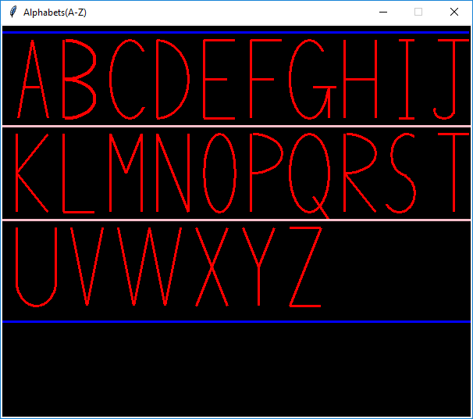

**Lower Case**

**Program:**

from graphics import *

w=GraphWin("Small Alphabets(a-z",640,600)

l=Line(Point(0,10),Point(640,10))

l.draw(w)

l.setWidth(3)

l.setOutline("red")

l=Line(Point(0,550),Point(650,550))

l.draw(w)

l.setWidth(3)

l.setOutline("red")

w.setBackground("black")

w.setBackground("black")

a1=Arc(Point(45,60),Point(95,120),40,280,"arc")

a1.draw(w)

a1.setWidth(3)

a1.setOutline("blue")

a2=Line(Point(90,60),Point(90,120))

a2.draw(w)

a2.setWidth(3)

a2.setOutline("blue")

a3=Arc(Point(90,115),Point(102,125),180,180,"arc")

a3.draw(w)

a3.setWidth(3)

a3.setOutline("blue")

b1=Line(Point(125,10),Point(125,120))

b1.draw(w)

b1.setWidth(3)

b1.setOutline("blue")

b2=Arc(Point(120,60),Point(170,120),140,-280,"arc")

b2.draw(w)

b2.setWidth(3)

b2.setOutline("blue")

c=Arc(Point(190,60),Point(240,120),50,260,"arc")

c.draw(w)

c.setWidth(3)

c.setOutline("blue")

d1=Line(Point(290,10),Point(290,120))

d1.draw(w)

d1.setWidth(3)

d1.setOutline("blue")

d2=Arc(Point(245,60),Point(295,120),40,280,"arc")

d2.draw(w)

d2.setWidth(3)

d2.setOutline("blue")

e1=Arc(Point(310,60),Point(360,120),45,300,"arc")

e1.draw(w)

e1.setWidth(3)

e1.setOutline("blue")

e2=Arc(Point(290,50),Point(350,90),10,-120,"arc")

e2.draw(w)

e2.setWidth(3)

e2.setOutline("blue")

f1=Line(Point(380,20),Point(380,120))

f1.draw(w)

f1.setWidth(3)

f1.setOutline("blue")

f2=Arc(Point(380,5),Point(410,35),0,180,"arc")

f2.draw(w)

f2.setWidth(3)

f2.setOutline("blue")

f3=Line(Point(380,60),Point(400,60))

f3.draw(w)

f3.setWidth(3)

f3.setOutline("blue")

g1=Line(Point(460,60),Point(460,140))

g1.draw(w)

g1.setWidth(3)

g1.setOutline("blue")

g2=Arc(Point(415,60),Point(465,120),40,280,"arc")

g2.draw(w)

g2.setWidth(3)

g2.setOutline("blue")

g3=Arc(Point(460,120),Point(415,160),0,-160,"arc")

g3.draw(w)

g3.setWidth(3)

g3.setOutline("blue")

h1=Line(Point(490,10),Point(490,120))

h1.draw(w)

h1.setWidth(3)

h1.setOutline("blue")

h2=Arc(Point(490,60),Point(530,100),0,180,"arc")

h2.draw(w)

h2.setWidth(3)

h2.setOutline("blue")

h3=Line(Point(530,80),Point(530,120))

h3.draw(w)

h3.setWidth(3)

h3.setOutline("blue")

i1=Line(Point(560,60),Point(560,120))

i1.draw(w)

i1.setWidth(3)

i1.setOutline("blue")

i2=Circle(Point(560,40),3)

i2.draw(w)

i2.setWidth(3)

i2.setOutline("blue")

j1=Line(Point(590,60),Point(590,150))

j1.draw(w)

j1.setWidth(3)

j1.setOutline("blue")

j2=Circle(Point(590,40),3)

j2.draw(w)

j2.setWidth(3)

j2.setOutline("blue")

j3=Arc(Point(590,130),Point(570,160),0,-90,"arc")

j3.draw(w)

j3.setWidth(3)

j3.setOutline("blue")

l1=Line(Point(0,180),Point(640,180))

l2=Line(Point(0,360),Point(640,360))

l1.draw(w)

l2.draw(w)

l1.setWidth(3)

l2.setWidth(3)

l1.setOutline("green")

l2.setOutline("green")

k1=Line(Point(50,190),Point(50,300))

k1.draw(w)

k1.setWidth(3)

k1.setOutline("blue")

k2=Line(Point(80,240),Point(50,270))

k2.draw(w)

k2.setWidth(3)

k2.setOutline("blue")

k3=Line(Point(60,260),Point(80,300))

k3.draw(w)

k3.setWidth(3)

k3.setOutline("blue")

l1=Line(Point(110,190),Point(110,300))

l1.draw(w)

l1.setWidth(3)

l1.setOutline("blue")

l2=Arc(Point(130,280),Point(110,310),180,90,"arc")

l2.draw(w)

l2.setWidth(3)

l2.setOutline("blue")

m1=Line(Point(150,240),Point(150,300))

m1.draw(w)

m1.setWidth(3)

m1.setOutline("blue")

m2=Arc(Point(150,240),Point(180,270),180,-200,"arc")

m2.draw(w)

m2.setWidth(3)

m2.setOutline("blue")

m3=Line(Point(180,260),Point(180,300))

m3.draw(w)

m3.setWidth(3)

m3.setOutline("blue")

m4=Arc(Point(180,240),Point(210,270),180,-200,"arc")

m4.draw(w)

m4.setWidth(3)

m4.setOutline("blue")

m5=Line(Point(210,250),Point(210,300))

m5.draw(w)

m5.setWidth(3)

m5.setOutline("blue")

n1=Line(Point(240,240),Point(240,300))

n1.draw(w)

n1.setWidth(3)

n1.setOutline("blue")

n2=Arc(Point(240,240),Point(270,270),180,-200,"arc")

n2.draw(w)

n2.setWidth(3)

n2.setOutline("blue")

n3=Line(Point(270,260),Point(270,300))

n3.draw(w)

n3.setWidth(3)

n3.setOutline("blue")

o=Oval(Point(290,240),Point(340,300))

o.draw(w)

o.setWidth(3)

o.setOutline("blue")

p1=Line(Point(360,240),Point(360,340))

p1.draw(w)

p1.setWidth(3)

p1.setOutline("blue")

p2=Arc(Point(355,240),Point(405,300),140,-280,"arc")

p2.draw(w)

p2.setWidth(3)

p2.setOutline("blue")

q1=Line(Point(470,240),Point(470,350))

q1.draw(w)

q1.setWidth(3)

q1.setOutline("blue")

q2=Arc(Point(425,240),Point(475,300),40,280,"arc")

q2.draw(w)

q2.setWidth(3)

q2.setOutline("blue")

q3=Line(Point(470,350),Point(500,300))

q3.draw(w)

q3.setWidth(3)

q3.setOutline("blue")

r1=Line(Point(520,240),Point(520,300))

r1.draw(w)

r1.setWidth(3)

r1.setOutline("blue")

r2=Arc(Point(520,242),Point(580,258),180,-100,"arc")

r2.draw(w)

r2.setWidth(3)

r2.setOutline("blue")

s1=Arc(Point(580,240),Point(610,270),25,260,"arc")

s1.draw(w)

s1.setWidth(3)

s1.setOutline("blue")

s2=Arc(Point(580,270),Point(610,300),105,-270,"arc")

s2.draw(w)

s2.setWidth(3)

s2.setOutline("blue")

t1=Line(Point(50,370),Point(50,470))

t1.draw(w)

t1.setWidth(3)

t1.setOutline("blue")

t2=Arc(Point(50,450),Point(70,480),180,120,"arc")

t2.draw(w)

t2.setWidth(3)

t2.setOutline("blue")

t3=Line(Point(40,420),Point(60,420))

t3.draw(w)

t3.setWidth(3)

t3.setOutline("blue")

u1=Line(Point(100,420),Point(100,470))

u1.draw(w)

u1.setWidth(3)

u1.setOutline("blue")

u2=Arc(Point(100,450),Point(130,480),170,200,"arc")

u2.draw(w)

u2.setWidth(3)

u2.setOutline("blue")

u3=Line(Point(130,420),Point(130,480))

u3.draw(w)

u3.setWidth(3)

u3.setOutline("blue")

v1=Line(Point(160,420),Point(175,480))

v1.draw(w)

v1.setWidth(3)

v1.setOutline("blue")

v2=Line(Point(190,420),Point(175,480))

v2.draw(w)

v2.setWidth(3)

v2.setOutline("blue")

w1=Line(Point(220,420),Point(235,480))

w1.draw(w)

w1.setWidth(3)

w1.setOutline("blue")

w2=Line(Point(250,420),Point(235,480))

w2.draw(w)

w2.setWidth(3)

w2.setOutline("blue")

w3=Line(Point(250,420),Point(265,480))

w3.draw(w)

w3.setWidth(3)

w3.setOutline("blue")

w4=Line(Point(280,420),Point(265,480))

w4.draw(w)

w4.setWidth(3)

w4.setOutline("blue")

x1=Line(Point(310,420),Point(340,480))

x1.draw(w)

x1.setWidth(3)

x1.setOutline("blue")

x2=Line(Point(340,420),Point(310,480))

x2.draw(w)

x2.setWidth(3)

x2.setOutline("blue")

y1=Line(Point(370,420),Point(390,480))

y1.draw(w)

y1.setWidth(3)

y1.setOutline("blue")

y2=Line(Point(410,420),Point(380,515))

y2.draw(w)

y2.setWidth(3)

y2.setOutline("blue")

y3=Arc(Point(360,510),Point(380,520),0,-110,"arc")

y3.draw(w)

y3.setWidth(3)

y3.setOutline("blue")

z1=Line(Point(440,420),Point(480,420))

z1.draw(w)

z1.setWidth(3)

z1.setOutline("blue")

z2=Line(Point(480,420),Point(440,480))

z2.draw(w)

z2.setWidth(3)

z2.setOutline("blue")

z3=Line(Point(440,480),Point(480,480))

z3.draw(w)

z3.setWidth(3)

z3.setOutline("blue")

**Output:**

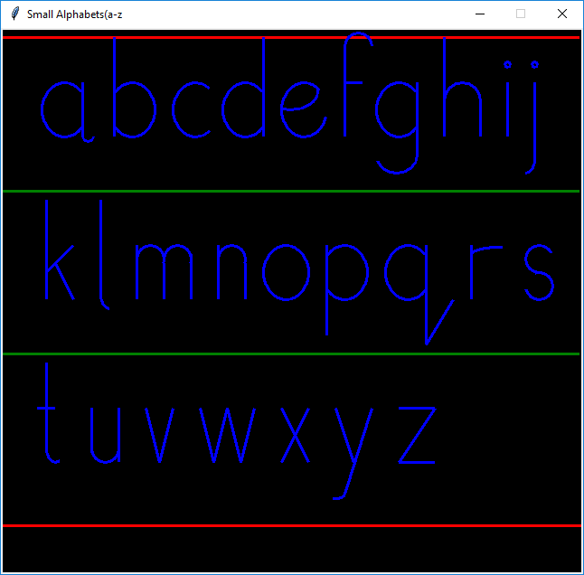

**Ex no: 4**

**Date: 4-12-2019**

**Problem Statement:**

Draw the Target symbol (a set of concentric circles, alternating red and white) in a graphics window that is 200 pixels wide by 200 pixels high. Hint: Draw the largest circle first in red, then draw the next smaller circle in white, then draw the next smaller circle in red.

**Program:**

from graphics import *

w=GraphWin("Shapes",700,700)

label=Text(Point(300,20),"Circle")

label.draw(w)

label.setStyle("bold")

center=Point(400,400)

circ=Circle(center,270)

circ.setFill("red")

circ.setWidth(3)

circ.draw(w)

center=Point(410,400)

circ=Circle(center,180)

circ.setFill("white")

circ.setWidth(3)

circ.draw(w)

center=Point(420,400)

circ=Circle(center,90)

circ.setFill("red")

circ.setWidth(3)

circ.draw(w)

**Output:**

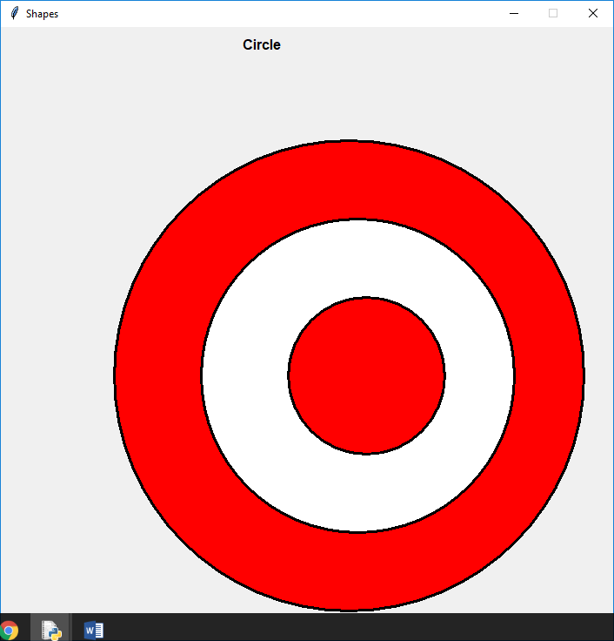

**Ex no: 5**

**Date: 4-12-2019**

**Problem Statement:**

Draw a simple traffic light in a graphics window that is 200 pixels wide by 200 pixels high. The three lights should have a diameter of 50 pixels each, and the traffic light should be centered in the graphics window.

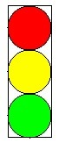

**Program:**

from graphics import *

w=GraphWin("Shapes",200,200)

label=Text(Point(50,10),"Traffic light")

label.draw(w)

label.setStyle("bold")

rect=Rectangle(Point(20,20),Point(80,200))

rect.draw(w)

rect.setWidth(3)

center=Point(50,50)

circ=Circle(center,30)

circ.setFill("red")

circ.setWidth(3)

circ.draw(w)

center=Point(50,110)

circ=Circle(center,30)

circ.setFill("yellow")

circ.setWidth(3)

circ.draw(w)

center=Point(50,170)

circ=Circle(center,30)

circ.setFill(color_rgb(0,255,0))

circ.setWidth(3)

circ.draw(w)

**Output:**

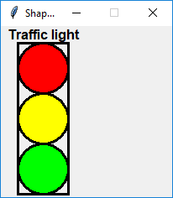

**Ex no: 6**

**Date: 4-12-2019**

**Problem Statement:**

Create the image shown below.

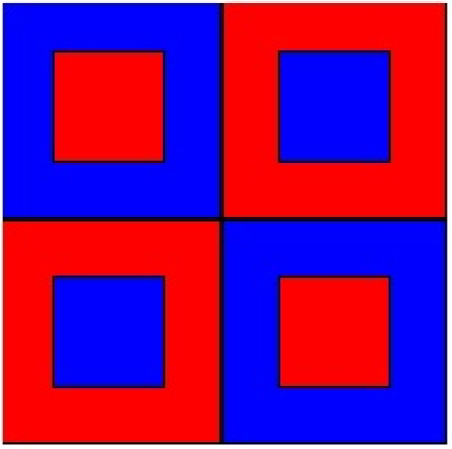

**Program:**

from graphics import *

w=GraphWin("line Drawing",600,600)

rect=Rectangle(Point(0,0),Point(300,300))

rect.setWidth(5)

rect.draw(w)

rect.setFill("blue")

rect=Rectangle(Point(75,75),Point(225,225))

rect.setWidth(5)

rect.draw(w)

rect.setFill("red")

rect=Rectangle(Point(300,0),Point(600,300))

rect.setWidth(5)

rect.draw(w)

rect.setFill("red")

rect=Rectangle(Point(375,75),Point(525,225))

rect.setWidth(5)

rect.draw(w)

rect.setFill("blue")

rect=Rectangle(Point(0,300),Point(300,600))

rect.setWidth(5)

rect.draw(w)

rect.setFill("red")

rect=Rectangle(Point(75,375),Point(225,525))

rect.setWidth(5)

rect.draw(w)

rect.setFill("blue")

rect=Rectangle(Point(300,300),Point(600,600))

rect.setWidth(5)

rect.draw(w)

rect.setFill("blue")

rect=Rectangle(Point(375,375),Point(525,525))

rect.setWidth(5)

rect.draw(w)

rect.setFill("red")

**Output:**

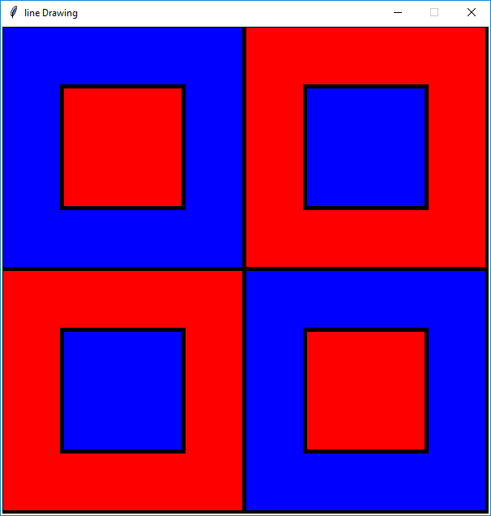

**Ex no: 7**

**Date: 12-12-2019**

**Problem Statement:**

Create a checkerboard of white and black squares in a graphics window that is 200 pixels wide by 200 pixels high. Each square should be 25 X 25. Can you simplify this program using loops?

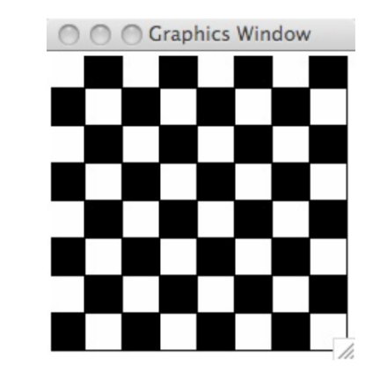

**Program:**

from graphics import *

w=GraphWin("chessboard",700,700)

label=Text(Point(300,50),"ChessBoard")

label.draw(w)

a="black"

b="white"

x=100

y=100

for j in range(8):

for i in range(8):

l=Rectangle(Point(x,y),Point(x+50,y+50))

l.draw(w)

if (i+j)%2!=0:

l.setFill(a)

else:

l.setFill(b)

x=x+50

y=y+50

x=100

**Output:**

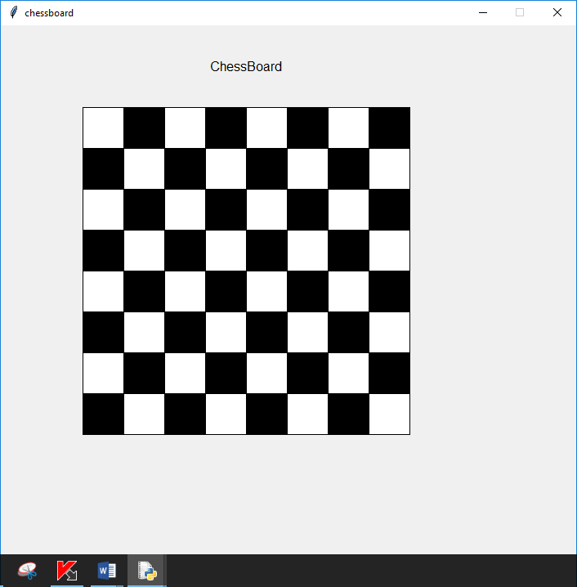

**Ex no: 8**

**Date: 12-12-2019**

**Problem Statement:**

Write a Python program to show Snowman using basic shapes

**Program:**

from graphics import*

x=400

y=500

win=GraphWin("Snowman",x,y)

label=Text(Point(70,70),"Snowman")

label.draw(win)

label.setStyle("bold")

label.setTextColor("red")

rect=Rectangle(Point(166,30),Point(218,70))

rect.draw(win)

rect.setFill("blue")

#big circle

center=Point(190,230)

circ=Circle(center,80)

circ.draw(win)

circ.setFill("white")

circ.setOutline("white")

#scraf

r=Polygon(Point(150,150),Point(140,160),

Point(150,180),Point(200,130))

# Point(180,150),Point(190,160))

r.setFill("lightgreen")

r.setWidth(3)

r.setOutline("lightgreen")

r.draw(win)

r=Oval(Point(150,170),Point(230,130))

r.draw(win)

r.setFill("pink")

r.setWidth(3)

r.setOutline("lightgreen")

#small circle

center=Point(190,117)

circ=Circle(center,40)

circ.draw(win)

circ.setOutline("white")

circ.setFill("white")

rect=Rectangle(Point(145,70),Point(237,80))

rect.draw(win)

rect.setFill("blue")

#left eye

center=Point(170,107)

circ=Circle(center,7)

circ.setFill('black')

circ.draw(win)

#right eye

center=Point(210,107)

circ=Circle(center,7)

circ.setFill('black')

circ.draw(win)

#nose

l=Line(Point(185,115),Point(200,118))

l.draw(win)

l.setFill("orange")

l.setWidth(5)

l=Line(Point(200,116),Point(182,130))

l.draw(win)

l.setFill("orange")

l.setWidth(5)

#smile

r=Arc(Point(160,57),Point(221,137),230,80,"arc")

r.draw(win)

r.setWidth(5)

#buttons

center=Point(190,200)

circ=Circle(center,8)

circ.setFill('red')

circ.draw(win)

center=Point(190,230)

circ=Circle(center,8)

circ.setFill('blue')

circ.draw(win)

center=Point(190,260)

circ=Circle(center,8)

circ.setFill('green')

circ.draw(win)

win.setBackground('black')

**Output:**

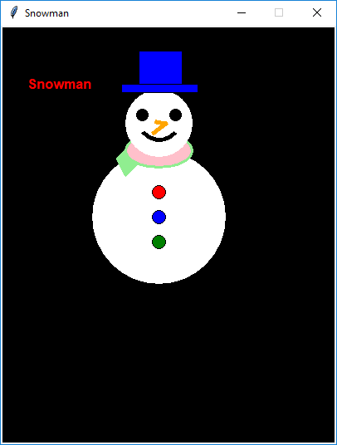

**Ex no: 9**

**Date: 12-12-2019**

**Problem Statement:**

Write a Python program to show House using basic shapes

**Program:**

from graphics import *

w=GraphWin("house",800,700)

triangle=Polygon(Point(370,420),Point(420,370),Point(470,420))

triangle.setFill('brown')

triangle.setWidth(4)

triangle.draw(w)

w.setBackground(color_rgb(153,217,255))

center=Point(0,100)

circ=Circle(center,200)

circ.setFill('yellow')

circ.draw(w)

rect=Rectangle(Point(370,570),Point(470,420))

rect.setFill(color_rgb(255,128,0))

rect.draw(w)

rect.setWidth(3)

rect=Rectangle(Point(470,570),Point(680,420))

rect.setFill(color_rgb(255,128,0))

rect.setWidth(3)

rect.draw(w)

rect=Rectangle(Point(540,540),Point(614,470))

rect.setFill('brown')

rect.draw(w)

rect.setWidth(3)

rect=Rectangle(Point(390,520),Point(450,450))

rect.setFill(color_rgb(24,168,216))

rect.draw(w)

rect.setWidth(3)

line=Line(Point(418,520),Point(418,450))

line.setWidth(3)

line.draw(w)

line=Line(Point(390,485),Point(450,485))

line.setWidth(3)

line.draw(w)

t=Polygon(Point(420,370),Point(620,370),Point(680,420))

t.setFill('brown')

t.setWidth(3)

t.draw(w)

t=Polygon(Point(420,370),Point(680,420),Point(470,420))

t.setFill('brown')

t.setWidth(3)

t.draw(w)

center=Point(550,530)

circ=Circle(center,4)

circ.setFill(color_rgb(255,242,0))

circ.draw(w)

**Output:**

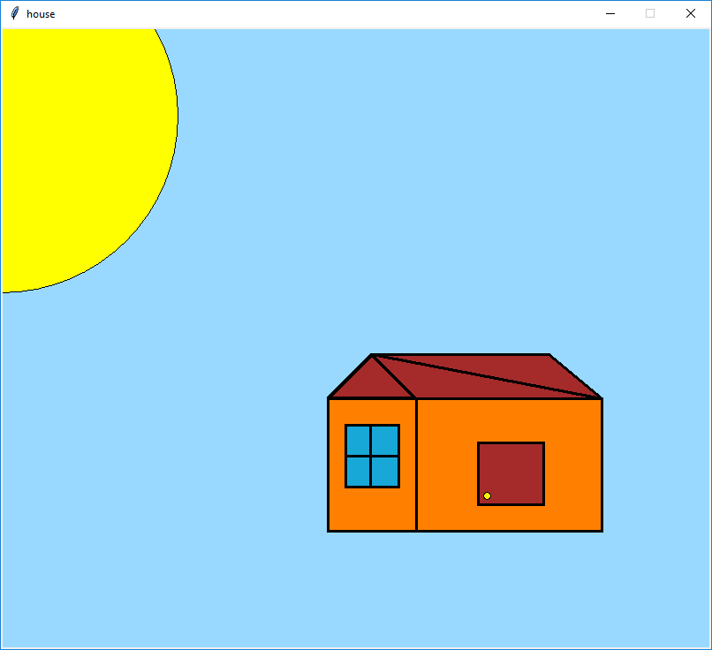

**Ex no: 10**

**Date: 12-12-2020**

**Problem Statement:**

Colour handling in opencv

**Program:**

import cv2

image=cv2.imread('face.jpg')

cv2.imshow('original',image)

cv2.circle(image,(200,85),25,(0,255,0),-1)

cv2.circle(image,(40,75),25,(0,0,255),-1)

cv2.circle(image,(110,100),50,(255,255,0),3)

cv2.imshow("test image",image)

cv2.waitKey(0)

cv2.destoryAllwindow()

**Output:**

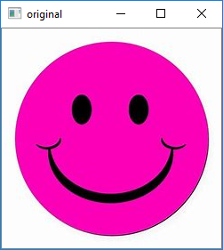 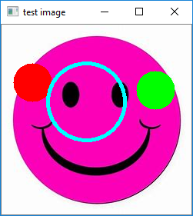

**Ex no: 11**

**Date: 02-01-2020**

**Problem Statement:**

Negative of image using OpenCv.

**Program:**

import cv2

image=cv2.imread('clown1.jpg')

cv2.imshow('original',image)

img_not=cv2.bitwise_not(image)

cv2.imshow("Negative",img_not)

cv2.waitKey(0)

cv2.destoryAllWindows()

**Output:**

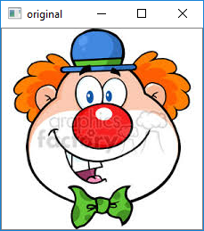 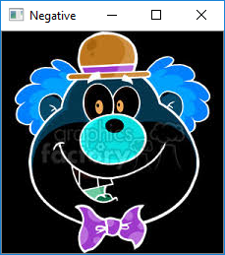

**Ex no: 12**

**Date: 02-01-2020**

**Problem Statement:**

Thresholding using OpenCv.

**Program:**

from cv2 import *

from matplotlib import pyplot as plt

img1=cv2.imread('download.jpg')

img=cv2.cvtColor(img1,cv2.COLOR_BGR2RGB)

ret,thresh1=threshold(img1,120,255,THRESH_BINARY)

ret,thresh2=threshold(img1,120,255,THRESH_BINARY_INV)

ret,thresh3=threshold(img1,120,255,THRESH_TRUNC)

ret,thresh4=threshold(img1,120,255,THRESH_TOZERO)

ret,thresh5=threshold(img1,120,255,THRESH_TOZERO_INV)

images=[img,thresh1,thresh2,thresh3,thresh4,thresh5]

titles=["Original","THRESH_BINARY","THRESH_BINARY_INV","THRESH_TRUNC","THRESH_TOZERO","THRESH_TOZERO_INV"]

for i in range(6):

plt.subplot()

plt.imshow(images[i],cmap="gray")

plt.title(titles[i])

plt.xticks([])

plt.yticks([])

plt.show()

waitKey(0)

destroyAllWindows()

**Output:**

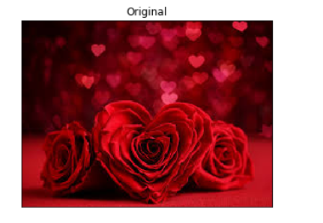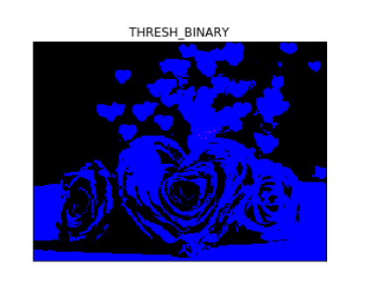

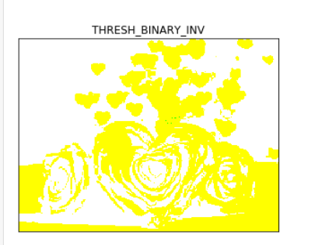 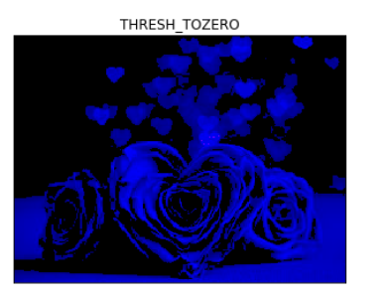 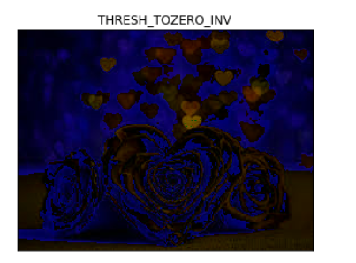

**Ex no: 13**

**Date: 02-01-2020**

**Problem Statement:**

Power law transformation using OpenCv.

**Program:**

import cv2

import numpy as np

img=cv2.imread('boat.jpg')

cv2.imshow('Original',img)

im1=img/255.0

im_power_law_transformation=cv2.pow(im1,0.6)

cv2.imshow("power law tansformation",im_power_law_transformation)

cv2.waitKey(0)

cv2.destroyAllWindows()

**Output:**

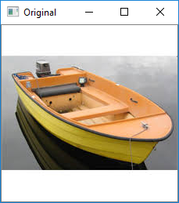 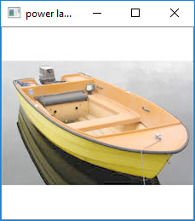

**Ex no: 14**

**Date: 09-01-2020**

**Problem Statement:**

Log Transformation using OpenCv

**Program:**

import cv2

import numpy as np

img=cv2.imread('flower.jpg')

img_log=(np.log(img+1)/(np.log(1+np.max(img))))*255

img_log=np.array(img_log,dtype=np.uint8)

cv2.imshow('log_image',img_log)

cv2.imshow('Original',img)

cv2.waitKey(0)

cv2.destroyAllWindows()

**Output:**

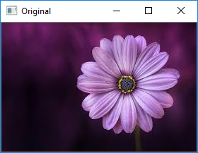 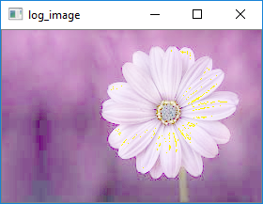

**Ex no: 15**

**Date: 09-01-2020**

**Problem Statement:**

Contrast Stretching using OpenCv

**Program:**

import cv2

from matplotlib import pyplot as plt

img1=cv2.imread('images.jpg')

img=cv2.cvtColor(img1,cv2.COLOR_BGR2RGB)

nmax=255

nmin=0

out=cv2.normalize(img1,None,alpha=nmin,beta=nmax,norm_type=cv2.NORM_MINMAX)

plt.subplot(1,2,1),plt.imshow(img)

plt.title('original'),plt.xticks([]),plt.yticks([])

plt.subplot(1,2,2),plt.imshow(out,cmap='gray')

plt.title('output image'),plt.xticks([]),plt.yticks([])

plt.show()

**Output:**

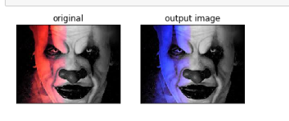

**Ex no: 16**

**Date: 09-01-2020**

**Problem Statement:**

Brightness using OpenCv

**Program:**

from cv2 import *

from matplotlib import pyplot as plt

x=30

img=cv2.imread('flower.jpg')

img1=cv2.imread('flower.jpg')

img=cv2.cvtColor(img,cv2.COLOR_BGR2RGB)

m=len(img)

n=len(img[0])

bright=img1

for i in range(1,m,1):

for j in range(1,n,1):

bright[i,j]=img[i,j]+x

plt.subplot(1,2,1)

plt.imshow(img,cmap='gray')

plt.title('Original Image')

plt.xticks([])

plt.yticks([])

plt.subplot(1,2,2)

plt.imshow(bright,cmap='gray')

plt.title('Brighter Image')

plt.xticks([])

plt.yticks([])

plt.show()

**Output:**

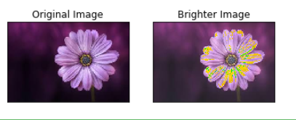

**Ex no: 17**

**Date: 09-01-2020**

**Problem Statement:**

Histogram Processing using OpenCv.

**Program:**

import cv2

import numpy as np

from matplotlibimport pyplot as plt

%matplotlib inline

img=cv2.imread('flower.jpg')

cv2.imshow("original",img)

histogram=cv2.calcHist([img],[0],None,[256],[0,256])

plt.hist(img.ravel(),256,[0,256]);plt.show();

color=('b','g','r')

for _i,col in enumerate(color):

histogram1=cv2.calcHist([img],[i],None,[256],[0,256])

plt.plot(histogram1,color=col)

plt.xlim([0,256])

plt.show()

cv2.waitKey(0)

cv2.distoryAllWindows()

**Output:**

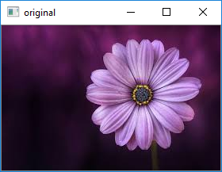

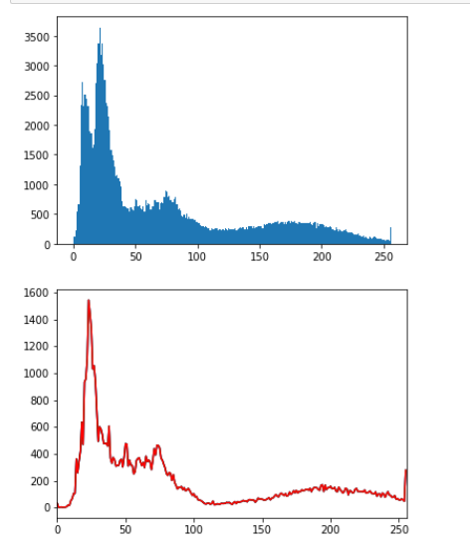

**Ex no: 18**

**Date: 16-01-2020**

**Problem Statement:**

Average Filter using OpenCv

**Program:**

import cv2

import numpy as np

image=cv2.imread('elephant.jpg')

cv2.imshow('original image',image)

avg=cv2.blur(image,(3,3))

cv2.imshow('Average filter',avg)

cv2.waitKey(0)

cv2.destroyAllWindows()

**Output:**

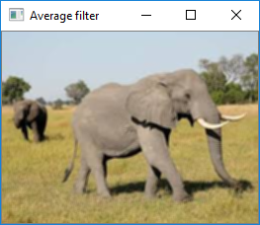 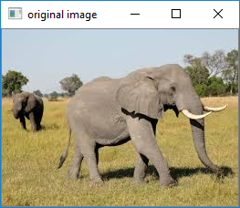

**Ex no: 19**

**Date: 16-01-2020**

**Problem Statement:**

Median Filter using OpenCv

**Program:**

import cv2

import numpy as np

image=cv2.imread('elephant.jpg')

cv2.imshow('original image',image)

medi=cv2.medianBlur(image,5)

cv2.imshow('median filter',medi)

cv2.waitKey(0)

cv2.destroyAllWindows()

**Output:**

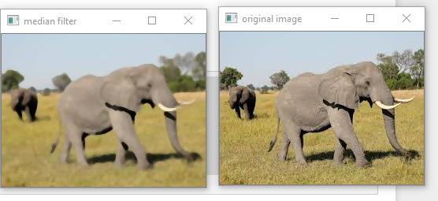

**Ex no: 20**

**Date: 16-01-2020**

**Problem Statement:**

Gaussian Blur using OpenCv

**Program:**

import cv2

import numpy as np

image=cv2.imread('elephant.jpg')

cv2.imshow('original image',image)

gauss=cv2.GaussianBlur(image,(7,7),0)

cv2.imshow('Gaussian filter',gauss)

cv2.waitKey(0)

cv2.destroyAllWindows()

**Output:**

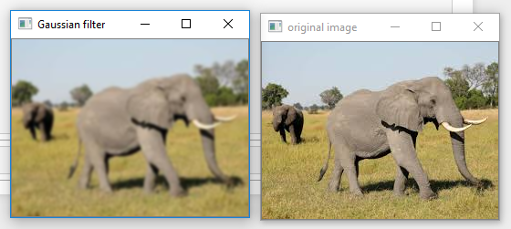

**Ex no: 21**

**Date: 16-01-2020**

**Problem Statement:**

Translation of image using OpenCv.

**Program:**

import cv2

import numpy as np

image=cv2.imread("translation.jpg")

height ,width=image.shape[:2]

quarter_height,quarter_width=height/4,width/4

T=np.float32([[1,0,quarter_width],[0,1,quarter_height]])

img_translation=cv2.warpAffine(image,T,(width,height))

cv2.imshow("original image",image)

cv2.imshow("Translation",img_translation)

cv2.waitKey()

cv2.destoryAllwindows()

**Output:**

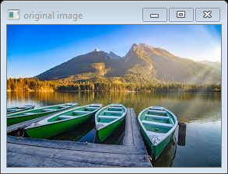 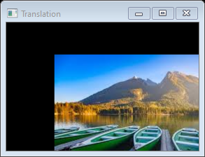

**Ex no: 22**

**Date: 28-01-2020**

**Problem Statement:**

Rotation of image using OpenCv.

**Program:**

import cv2

import numpy as np

image=cv2.imread("rotation.jpg")

height ,width=image.shape[0:2]

rotationMatrix=cv2.getRotationMatrix2D((width/2,height/2),90,.5)

rotationImage=cv2.warpAffine(image,rotationMatrix,(width,height))

cv2.imshow("original image",image)

cv2.imshow("Rotation Image",rotationImage)

cv2.waitKey(0)

cv2.destoryAllWindows()

**Output:**

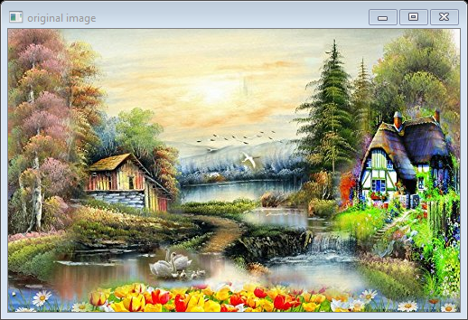 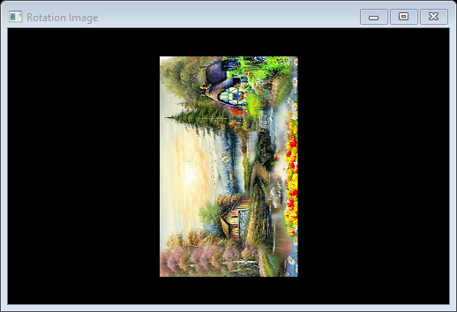

**Ex no: 23**

**Date: 28-01-2020**

**Problem Statement:**

Cropping of image using OpenCv.

**Program:**

import cv2

import numpy as np

image=cv2.imread("cropping.jpg")

height,width=image.shape[0:2]

startRow=int(height*.5)

startCol=int(width*.5)

endRow=int(height*.75)

endCol=int(width*.75)

croppingImage=image[startRow:endRow,startCol:endCol]

cv2.imshow("original image",image)

cv2.imshow("Cropping image",croppingImage)

cv2.waitKey(0)

cv2.destoryAllWindows()

**Output:**

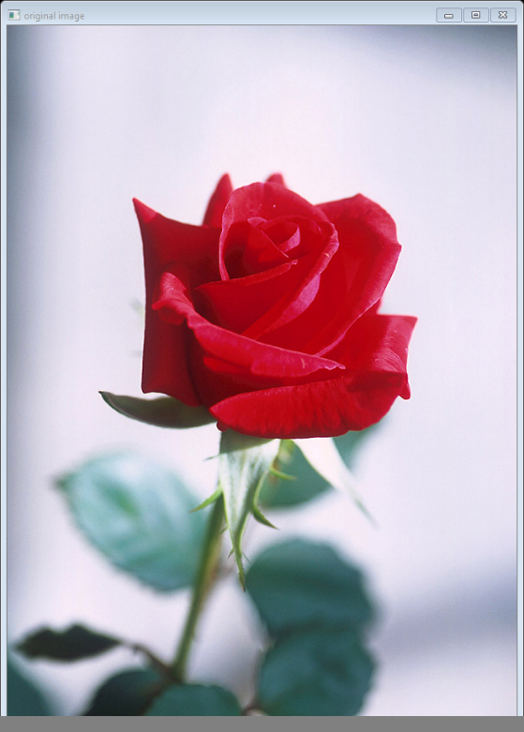 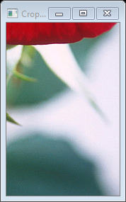

**Ex no: 24**

**Date: 28-01-2020**

**Problem Statement:**

Sharpening Filter using OpenCv.

**Program:**

import cv2

import numpy as np

#reading in and displaying our image

image=cv2.imread('sharp.jpg')

cv2.imshow('Original',image)

#create our sharpening kernel,it must equal to one eventually

kernel_sharpening=np.array([[-1,-1,-1],[-1,9,-1],[-1,-1,-1]])

sharpened=cv2.filter2D(image,-1,kernel_sharpening)

cv2.imshow('Image Sharpening',sharpened)

cv2.waitKey(0)

**Output:**

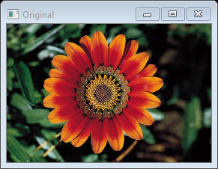 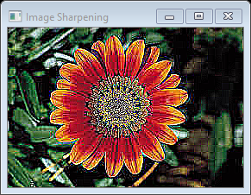

**Ex no: 25**

**Date: 28-01-2020**

**Problem Statement:**

Sobel and Laplacian Filter using OpenCv

**Program:**

import cv2

import numpy as np

from matplotlib import pyplot as plt

img=cv2.imread('sharp.jpg',0)

laplacian=cv2.Laplacian(img,cv2.CV_64F)

sobelx=cv2.Sobel(img,cv2.CV_64F,1,0,ksize=5)

sobely=cv2.Sobel(img,cv2.CV_64F,0,1,ksize=5)

plt.subplot(2,2,1),plt.imshow(img,cmap='gray')

plt.title('Original'),plt.xticks([]),plt.yticks([])

plt.subplot(2,2,2),plt.imshow(laplacian,cmap='gray')

plt.title('Laplacian'),plt.xticks([]),plt.yticks([])

plt.subplot(2,2,3),plt.imshow(sobelx,cmap='gray')

plt.title('sobelx'),plt.xticks([]),plt.yticks([])

plt.subplot(2,2,4),plt.imshow(sobely,cmap='gray')

plt.title('sobely'),plt.xticks([]),plt.yticks([])

plt.show()

**Output:**

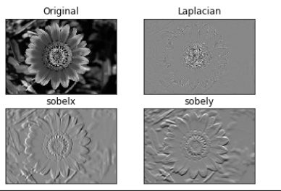

**Ex no: 26**

**Date: 05-02-2020**

**Problem Statement:**

Absolute sharpening using OpenCv

**Program:**

import cv2

import numpy as np

from matplotlib import pyplot as plt

img=cv2.imread('Capture.jpg',0)

sobelx=cv2.Sobel(img,cv2.CV_64F,1,0,ksize=5)

sobely=cv2.Sobel(img,cv2.CV_64F,0,1,ksize=5)

abs_sobelx64f=np.absolute(sobelx)

sobelx_8u=np.uint8(abs_sobelx64f)

plt.subplot(1,3,1),plt.imshow(img,cmap='gray')

plt.title('Original'),plt.xticks([]),plt.yticks([])

plt.subplot(1,3,2),plt.imshow(sobelx,cmap='gray')

plt.title('sobel x'),plt.xticks([]),plt.yticks([])

plt.subplot(1,3,3),plt.imshow(sobelx_8u,cmap='gray')

plt.title('sobel y'),plt.xticks([]),plt.yticks([])

plt.show()

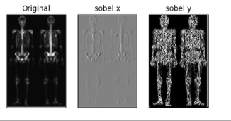

**Ex no: 27**

**Date: 05-02-2020**

**Problem Statement:**

Color complement using OpenCv

**Program:**

.

import cv2

img = cv2.imread('sharp.jpg')

comp_image = 255 - img

cv2.imshow('original image',img)

cv2.imshow("Complementary image",comp_image)

cv2.waitKey(0)

cv2.destoryAllWindows()

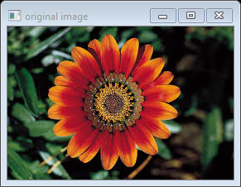

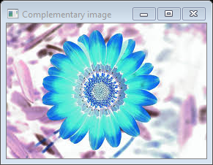

**Ex no: 19**

**Date:**

**Problem Statement:**

Spatial filters

**Program:**

import cv2

import numpy as np

image=cv2.imread('elephant.jpg')

cv2.imshow('original image',image)

kernel_3x3=np.ones((3,3),np.float32)/9

blurred=cv2.filter2D(image,-1,kernel_3x3)

cv2.imshow('3*3 kernel blurring',blurred)

cv2.waitKey(0)

cv2.destoryAllWindow()

**Output:**

 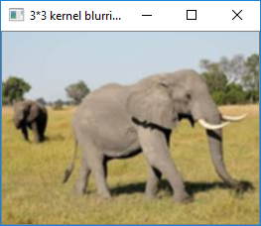

**Ex no:**

**Date:**

**Problem Statement:**

Histogram processing by applied mask

**Program:**

import cv2

import numpy as np

from matplotlib import pyplot as plt

img=cv2.imread('flower.jpg',0)

%matplotlib inline

mask= np.zeros(img.shape[:2],np.uint8)

mask[50:200,50:400]=255

masked_img=cv2.bitwise_and(img,img,mask=mask)

hist_full=cv2.calcHist([img],[0],None,[256],[0,256])

hist_mask=cv2.calcHist([img],[0],mask,[256],[0,256])

plt.subplot(221),plt.imshow(img,'gray')

plt.subplot(222),plt.imshow(mask,'gray')

plt.subplot(223),plt.imshow(masked_img,'gray')

plt.subplot(224),plt.plot(hist_full),plt.plot(hist_mask)

plt.xlim([0,256])

plt.show()

**Output:**

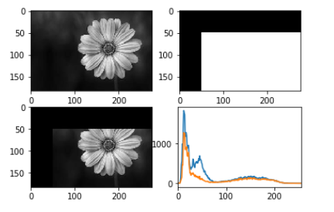

Color Slicing using OpenCv.

3D Scatter plot of nemo fish using OpenCv.

Smoothing and Sharpening using OpenCv(Use Skeleton Image).

31) Spatial Filtering.

32) Histogram Equilization.

import cv2

import numpy as np

import matplotlib.pyplot as plt

from matplotlib.colors import hsv_to_rgb

%matplotlib inline

nemo=cv2.imread('1.jpg')

plt.imshow(nemo)

plt.show()

nemo=cv2.cvtColor(nemo,cv2.COLOR_BGR2RGB)

plt.imshow(nemo)

plt.show()

hsv_nemo=cv2.cvtColor(nemo,cv2.COLOR_BGR2HSV)

plt.imshow(hsv_nemo)

plt.show()

light_orange=(1,190,200)

dark_orange=(18,255,255)

lo_squre=np.full((10,10,3),light_orange,dtype=np.uint8)/255.0

do_squre=np.full((10,10,3),dark_orange,dtype=np.uint8)/255.0

plt.subplot(1,2,1)

plt.imshow(hsv_to_rgb(do_squre))

plt.subplot(1,2,2)

plt.imshow(hsv_to_rgb(lo_squre))

plt.show()

mask=cv2.inRange(hsv_nemo,light_orange,dark_orange)

result=cv2.bitwise_and(nemo,nemo,mask=mask)

plt.subplot(1,2,1)

plt.imshow(mask,cmap="gray")

plt.subplot(1,2,2)

plt.imshow(result)

plt.show()

